Revised dimensions of specimens for Notched Three Point Bend test (in mm with tolerance of 5 mm):

Name D B a L S

A1 15 20 7.5 150 130

A2 20 15 10 150 130

A3 20 30 10 200 180

A4 30 20 15 200 180

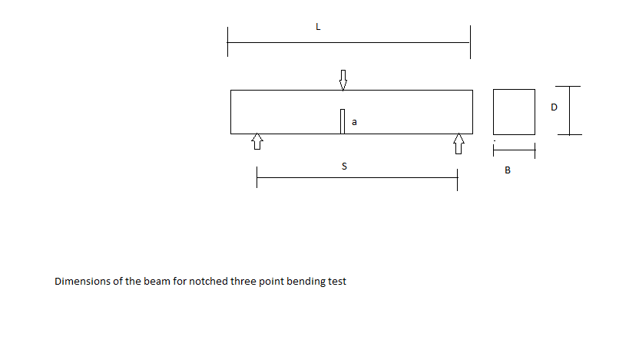

L : Total Length of specimen.

B : Widht of Specimen.

D : Depth of Specimen.

S : Distance between simple supports.

a : Depth/Height of notch.